COLLEGE OF ENGINEERING & TECHNOLOGY
(A Constituent & Autonomous College of BijuPatnaik University of Technology, Odisha)
Techno Campus, P.O.-MahalaxmiVihar
BHUBANESWAR-751029 ODISHA, INDIA
NAAC ‘A’

Tender Notice No.03/Con./CET Dated: 05.04.2021

TENDER CALL NOTICE

Sealed tenders are invited from Original Manufacturers / Authorized Distributors / Dealers / Registered / Govt Firms for supply of “Face Masks” to the Department of TEXTILE ENGINEERING of CET, Bhubaneswar in the prescribed format as per the requirements enclosed in the schedule of items given in bid documents. Bid documents with details terms & conditions are to be downloaded from CET website “www.cet.edu.in”.

The tenders along with the tender cost and EMD as given in bid documents in the sealed envelope should be superscribed with "Tender for supply of face masks” to Department of TEXTILE ENGINEERING" and should be submitted through Speed Post / Regd. Post only at Principal Office, CET, Bhubaneswar on or before 30.04.2021 at 4:00 P.M. No hand/courier delivery will be accepted. The tenderers must possess valid up-to-date GSTIN /Income tax clearance etc. The authority will not be held responsible for any postal delay. More details are available at our College Website: www.cet.edu.in. The authority reserves the right to accept/reject any or all tenders without assigning any reason thereof. No correspondence in this regard will be entertained. The technical bids and financial bids must be submitted separately.

Sd/-
PRINCIPAL

BID PARTICULARS AND INSTRUCTIONS OF TENDER NOTICE
FOR SUPPLY OF
Face masks
FOR
DEPARTMENT OF TEXTILE ENGINEERING
Bid Ref. No.03/Con./CET Dated: 05.04.2021

COLLEGE OF ENGINEERING AND TECHNOLOGY
(A Constituent College of BijuPatnik University of Technology, Odisha)
Techno Campus, P.O.- MahalaxmiVihar , BHUBANESWAR-751029 ODISHA, INDIA

Bid Ref. No.03/Con./CET Dated: 05.04.2021

NAAC ‘A’ | COLLEGE OF ENGINEERING & TECHNOLOGY  (A Constituent & Autonomous College of BijuPatnaik University  of Technology, Odisha)  Techno Campus, P.O.- MahalaxmiVihar  BHUBANESWAR-751029 ODISHA, INDIA

1.0 TENDER PARTICULARS AND SCHEDULE :
1. 1.Last Date of Submission of Bids: 30.04.2021 up to 4:00 P.M
1.2.Technical Bid Opening Date: 30.04.2021 at 4:30 P.M
1.3. Price Bid Opening : To be intimated to eligible bidders after evaluation of Technical Bid.
1.4. Tender fee (Non-Refundable): Rs. 500/-(Rupees five hundred only) in the form of a DD/Pay Order favouring The Principal, College of Engineering and Technology payable at Bhubaneswar.
1.5. Earnest Money Deposit: The Bidder shall submit their tender along with EMD of Rs. 5,000/-. EMD should be in the form of Demand Draft/Banker’s Cheque/Bank Guarantee favoring: The Principal, College of Engineering and Technology, payable at Bhubaneswar. This Bank Guarantee should be valid for Bid Validity period mentioned in Clause 1 under SECTION II.

SECTION I: INVITATION FOR BIDS (IFB)

Sub: Sealed tenders are invited from Original Equipment Manufacturers (OEM) /Authorized Distributors /Dealers / Registered Firms for supply of “Face Masks”in the Department of Textile Engineering, College of Engineering and Technology (CET), Techno Campus, MahalaxmiVihar, Bhubaneswar – 751029, Orissa.

1.0 Scope of Work & Technical specifications:
Detailed scope of work and technical Specifications are as per enclosed Annexure I

2.0 Eligibility Criteria for bidders:

The eligibility criteria for pre-qualification of bidders are as under:

2.1. The bidder should be a registered firm. The bidder should furnish the registration certificate, GSTIN certificate, PAN No. along with the tender paper. Enclose Xerox copy of the supporting documents. In absence of such certificate, the Bid is liable to be rejected.

2.2.The bidder must be a reputed Original Manufacturer and/or the Authorised distributor/ Dealer of a reputed manufacturer. Original Manufacturers should provide all documents relating to their Manufacturing Capabilities. If the bidder is an Authorised Distributors/Dealer of a reputed manufacturer, necessary certificate to this effect from his manufacturer must be enclosed failing which the offer will be summarily rejected.The certificate so furnished should clearly incorporate the firm name and address from where after sales services shall be rendered. In absence of such authorization, the Bid is liable to be rejected.
2.3 All after sales support should be provided directly by the manufacturer only.
2.4. Products to be offered should be new, unused and of current design, not declared obsolete .

2.5 The tender(s) should have executed the similar nature work. Proofs of the same like PO copies, performance certificates, with address & contact details of the reference supply list should be submitted with the bid. In absence of supporting documents, the bid is liable to be rejected.

2.6 The bidder should not be black listed in any of the Gov. Organization. Undertaking in this regard must be submitted.

2.7 Before submission of the tender, please verify the eligibility criteria and ensure fulfilling all the terms and conditions.

3.0. Bid Submission:
The offer must be submitted in two parts in sealed envelope separately as Part-I (Technical Bid) and Part-II (Price Bid) in separate sealed envelopes. Both the bids shall be enclosed in another sealed envelope superscribed“Tender for supply of face masks” to Department of Textile Engineering, CET Bhubaneswar”and the address of the firm should be mentioned in the sender side of the envelope with phone number.

3.1 Part – I (Technical Bid) shall contain:

- Technical bid with full details including description of make & model of materials so as to enable technical assessment of the proposal. Technical bid must accompany at least 3 non refundable samples, which will be evaluated at our lab.

- An Undertaking / Authorization certificate as mentioned under Eligibility Criteria.

- Company Profile (as per PROFORMA I & II) along with all the supporting documents as desired.

- Non-Refundable Tender cost of Rs. 500/-(Rupees Five hundred only) in the form of DD / Pay Order favouringPrincipal, College of Engineering & Technology, payable at Bhubaneswar. (In case the tender document is downloaded from the website). Quotations without Tender cost shall be rejected.

Refundable Earnest Money Deposit (EMD): The bidder has to submit a Demand Draft/Banker’s Cheque/Pay Order/Bank Guarantee towards EMD amounting to Rs. 5,000/-in favour of Principal, College of Engineering and Technology payable at Bhubaneswar in any Nationalised Bank towards EMD. Without EMD, the tender will not be considered.

- Acceptance to the terms and conditions laid down in the tender document. Any deviation in the general terms and condition will lead to the rejection of the bid.

- All the documents submitted must be in the papers showing signature of the tenderer and printed office name of the tenderer on official seal.

- All the documents must be submitted in a sequential manner with separator/flags to help in quick scanning of the topics. Wherever possible, data in tabular form should be given.

If the technical offer contains any price information, the offer will be summarily rejected.

3.2 Part –II (Price Bid) should contain Only Price Details in the prescribed format as per Annexure-II with proper seal and signature of authorized person. Prices should be given in INR in both figures and words.

The sealed cover containing tender documents as per procedure indicated above should be submitted by Registered Post/Speed Post addressing to the Principal, College of Engineering & Technology, Techno-campus,MahaLaxmiVihar, Bhubaneswar-751029within the due date and time as stipulated in Tender Call Notice. The College is not responsible for postal delay. The sealed envelope must show the name of the tenderer and his address and should be super scribed as “Tender for supply of Face masks” to Department of Textile Engineering, CET Bhubaneswaron the top of the envelope.

4.0. Opening of Technical & Price Bid

Only the technical bids will be opened on 30.04.2021 at 4:00 P.M. Interested bidders may attend the technical bid opening as per the schedule date and time.

SECTION II: INSTRUCTION TO BIDDERS:

- Bid Validity
Bids shall be valid for minimum 120 Days from the date of opening of technical bid. A bid valid for a shorter period shall not be considered. CET-Bhubaneswar may ask bidders to extend the period of validity.

- Delivery:
The complete delivery as per our present requirement must be completed at Dept. of Textile Engineering, CET, Techno Campus, Ghatikia within 90 days from the date of P.O. to meet the time lines. The supplier must bear the charges of transportation, insurance, loading and unloading. However, separate order may be placed for additional quantities on the same rates on “As and When Required” basis within the Bid Validity period as above. CET-Bhubaneswar reserves the right to increase or decrease the Bill of material as per the requirement without any change in the rates quoted.

3.0 . Product Specifications & Compliance Statement
The bidder should quote the products strictly as per the tender specifications and only of desired / preferred brands. Complete technical details along with brand, specification, technical literature etc. highlighting the specifications must be supplied along with the technical bid. The compliance statements should be supported by authentic documents. Each page of the bid and cuttings / corrections shall be duly signed and stamped by the authorized signatory. Failure to comply with this requirement may result in the bid being rejected.

4.0. In case of any discrepancy between rates mentioned in figures and words, the later shall prevail. If there is a discrepancy between the unit price and the total price that is obtained by multiplying the unit price and quantity, the unit price shall prevail and the total price shall be corrected.

5.0.Materials must be properly packed against any damage up to the destination. The material should be directly supplied to Department of Department of Textile Engineering, CET, Ghatikia, Bhubaneswar. All the expenses involved in transportation of the equipment to CET, Bhubaneswar shall be borne by the Bidder. All aspects of safe delivery shall be the responsibility of the Bidder. CET-Bhubaneswar will have the right to reject the components / equipment as a whole supplied, if it does not comply with the specifications at any point of inspection.

6.0. CET-Bhubaneswar reserves the right to divide / split the order between more than one technically qualified bidder to meet the Technical Requirements and Delivery Schedule after getting satisfactory proof / physical inspection of the manufacturing capabilities of bidders.

7.0. Earnest Money is liable to be forfeited and bid is liable to be rejected, if the bidder withdraw or amends, impairs or derogates from the tender in any respect within the validity period of the tender.

8.0.The Earnest Money of all the unsuccessful bidders shall be returned as early as possible but within the Bid Validity period but not before 30 days from the date of Purchase Order. No interest will be payable by CET on the Earnest Money Deposit. The Earnest Money of successful bidder shall be returned after successful performance of the equipment.
9.0.If any component / part thereof is lost or rendered defective during transit, the supplier shall immediately arrange for the supply of the software and hardware or part thereof, as the case may be at no extra cost.

10.0. The rates should be quoted in Indian Rupees for delivery at the Site BOTH IN FIGURES & WORDS. All prices shall be fixed and shall not be subject to escalation of any description during the bid validity period.

11.0. Price quoted should beFOR College of Engineering & Technology, Bhubaneswar only.
The price should be inclusive of all taxes strictly as per the format of Annexure-II. However the bidder may give details of tax components like basic price, GST separately in the price bid in Annexure II. The offers which are not as per the format will be rejected.

12.0. CET, Bhubaneswar reserves the right to accept / reject the offers or cancel the whole tender proceedings without assigning any reason whatsoever. Offers through Email / Fax, etc and open offers shall not be accepted. Late / Delayed offers shall not be accepted under any circumstances. Incomplete offers shall be rejected outright. In case the specified date for the submission of offers being declared as a holiday for CET-Bhubaneswar, the bid-closing deadline shall stand extended to the next working day up to the same time.

13.0 Any attempt of negotiation direct or indirect on the part of the Tenderer with the authority to whom he has submitted the tender or authority who is competent finally to accept it after he has submitted his tender or any endeavour to secure any interest for an actual or prospective bidder or to influence by any means the acceptance of a particular tender will render the tender liable to be rejected.

14.0. The prospective bidders requiring any clarification about the contents detailed in the tender document may notify to CET-Bhubaneswar in writing at CET’s address. Clarifications received till 72 hours before the closing date / time of receipt of bids will be responded.

16.0. Unsatisfactory Performance
The Parties herein agree that CET-Bhubaneswar shall have the sole and discretionary right to assess the performance(s) of the Bidder components(s), either primary and or final, and CET-Bhubaneswar, without any liability what so ever, either direct or indirect, may reject the system(s) component(s) provided by the Bidder, in part or in its entirety, without any explanation to the Bidder, if found unsatisfactory and not up to level of the acceptance of CET-Bhubaneswar.

17.0 Penalty:
If the delivery is not carried out in time as specified in other part of the tender document, the tenderer/manufacturer will be charged @ 1 % (one per cent) per week of the total value of the concerned machine / equipment.
18. Discount:
Our Institute is a pioneer Institution in the field of Teaching and Research in Engineering and allied disciplines and do not run with profit motive.
As such we are availing price discount for purchase of equipment/instruments.
The rate of discount or any other Institutional benefit arising out of Govt. Policy etc., on each item may also be indicated in the bid specifically.
19.0. Disclaimer
This Tender / Request for Proposal (RFP) is not an offer by CET-Bhubaneswar, but an invitation for bidder’s response. No contractual obligation whatsoever shall arise from the RFP process.
20.0. Solving Disputes:
The Institution & the Tenderer shall make all efforts to resolve amicably by direct informal negotiation on any disagreement or dispute arising between them under or in connection with this contract.
All disputes arising out of the contract shall be referred to courts under the jurisdiction of the Bhubaneswar court only.
The above terms and conditions except those otherwise agreed upon shall form a part of the Purchase Order.
Sign on each page of this tender document and Return it along with the offer enclosing this part together with the Technical Offer.
** * The CET authority has all rights to accept / reject any tender without assigning any reasons there of.
SIGNATURE OF THE BIDDER WITH STAMP

SECTION III: SPECIAL CONDITIONS OF CONTRACT:

1.0.Price Basis
Price quoted should be in the prescribed format as per Annexure-II. The quoted price will be considered firm and no price escalation will be permitted during the bid validity period.

2.0. Billing:
Billing is to be made in the name of The Principal, Collegeof Engineering and Technology, Techno Campus, Mahalaxmivihar,Bhubaneswar-751029. The payment would be on the basis of the actual bill of material supplied and duly certified by concerned authority of CET.

- Payment
100% of invoice value after successful Supply at Department of Textile Engineering, College of Engineering and Technology, Bhubaneswar and submission of invoice.

SECTION IV: Technical Specifications:
The list of item with their technical specifications (minimum) is as follows:
Sl. No. | Items | Quantity | Specification
 | 2 layer 100% cotton face mask | 12000 nos | - The outer layer should be made up of Ikat fabric, 1 up 1 down cotton plain woven, 64-EPI, 52-PPI,  - The inner layer should be made up of white / gray fabric, 1 up 1 down cotton plain woven, 64-EPI, 60-PPI  - Total weight of the mask- 8 gms  - All the above parameters should be within +/- 3% tolerance level.  - CETB  (Autonomous)  Should be embroidered on the left half at the middle as shown below with bright contrast polyester thread to enhance visibility. The letter size should be such that the total area of embroidery should be approx 2’X1.25”.  - At the two edges replaceable knitted elastics bands should be provided in casings to anchor the mask comfortably round the ears.  - The images provided below are for reference, which may not be adhered to while placing the order. The bidder may provide better designs and specifications at a competitive price.  - Each Face mask should be packed in a poly pack having zip, then grouped into 50 pieces in a packet during delivery.

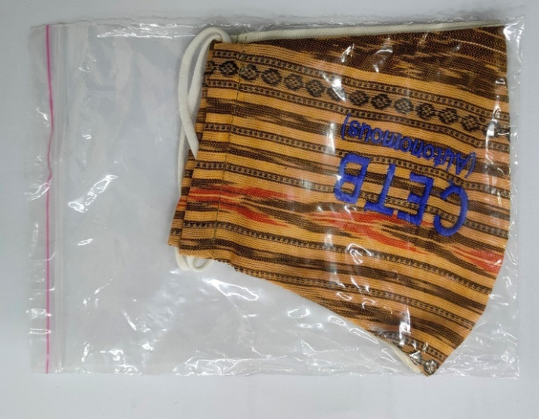

After packing it should look like this.

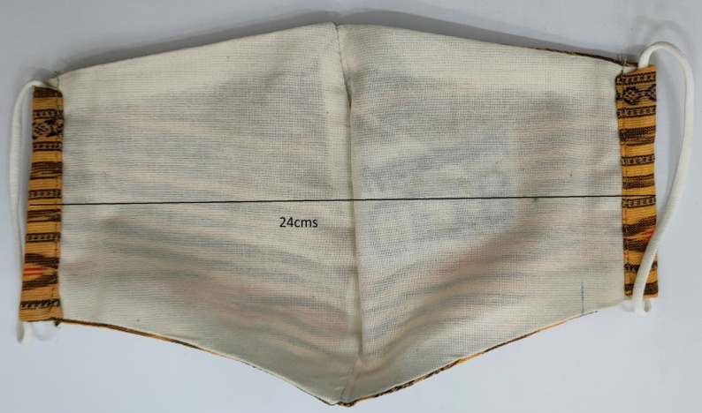
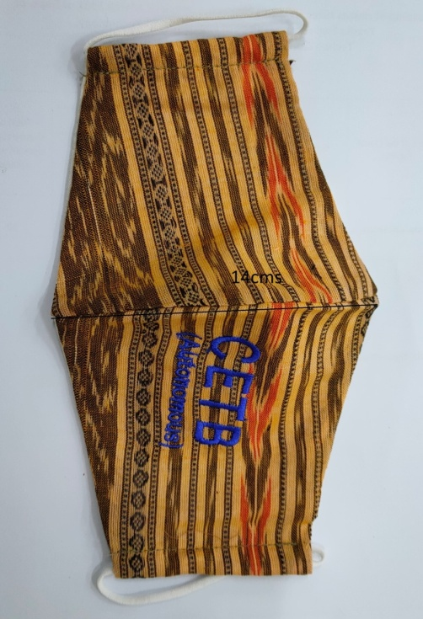

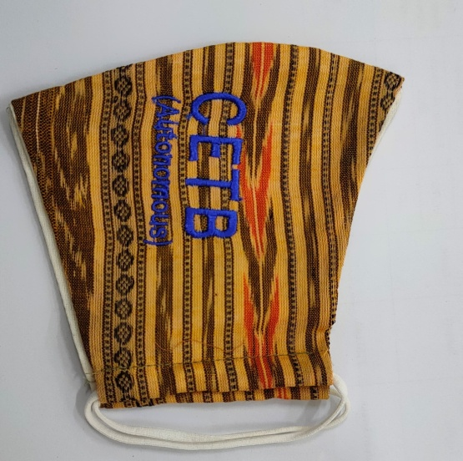

Image of mask intended to be procured

Annexure-I:

Technical Bid

PRE-QUALIFICATION/ELIGIBILITY
PROFORMA-I
PARTICULARS OF THE BIDDERS TO BE FURNISHED IN TECHNICAL BID FOR THE PURPOSE OF PRE-QUALIFICATION:
1 | Name of Organization/Firm/Company
2 | Address & Telephone Number
3 | Year of establishment
4 | Status of the Firm  (Company/Firm/Proprietary) enclose the supporting document
5 | Whether registered with the registrar of companies/registrar of firms. If so attach the copy of certificate.
6 | a)Name& Mobile Number of Directors/Partners/Proprietor | i)  ii)  iii)
7 | Whether registered GST If so, mention number& date. Furnish also copies of GSTIN registration certificate Mention the GSTIN No. enclose the relevant copies with clearance certificates
8 | Whether an assesses of income tax? If so, mention permanent account number. Furnish copy of PAN
9 | State Annual turnover of the company.  Furnish copies of audited balance sheet & profit & loss account certified by CA.
10 | Specify the specification with brand of material along with authorization of Original Manufacturer/Principal, if required.
11 | Status and details of disputes/Litigation/Arbitration, if any. | i)  ii)  iii)

I certify that I meet the eligibility criteria described in section 2 of the technical bid.

Place:
Date: Name, Signature & Seal of Bidder:

PRE-QUALIFICATION

PROFORMA-II

PARTICULAR IN RESPECT OF 3 MAJOR SUPPLIES IN LAST 3 YEARS
(TO BE FURNISHED IN TECHNICAL BID)

SL.  No. | Name of product | Model | Name and address of owner | Value | Date of supply | Stipulated time of completion | Actual time of completion

NB: Copies of Work Order / P.O., Completion certificate, Performance certificate must be attached.

Place:

Date:Signature of vendor

Annexure-II
(in the letter head of the bidder)
PRICE BID
1. Name of the Firm :
2. Official Address :
3. Contact person with designation :
4. Contact Info: e-mail & Mobile no. :
5. Tax Clearance up to last F.Y :
6. GSTIN/PAN :
7. The cost should be mentioned in INR inclusive of supply and testing of these items :

IMP: (i) The equipment must be of as per the specifications.
(ii) Price bid will not be considered for any particular item if make of it is not mentioned.
(iii) Quantity required are approximate which may change during finalization.
Sl. No. | Name of the items with technical specifications | Qty Reqd.  (approx.) | Detail technical specifications | Rate per unit item in Rs. | GST @  Per unit item in Rs. | Total amount in Rs.
1 | Face mask | 12000nos
TOTAL =

Date:
Place: Signature of the authorized person & seal

